# **TASK 3 : Infrastructure as Code (IaC) with Terraform**

Objective: Provision a local Docker container using Terraform.

Tools: Terraform, Docker

Deliverables: main.tf, execution logs.

Step :- 1

Log into AWS Console and Create new Instance Named Task3 and Select Ubuntu and create Key pair (.pem)

And Select Instance type t2.micro and Click Launch Instance.

Instance launched Successfully

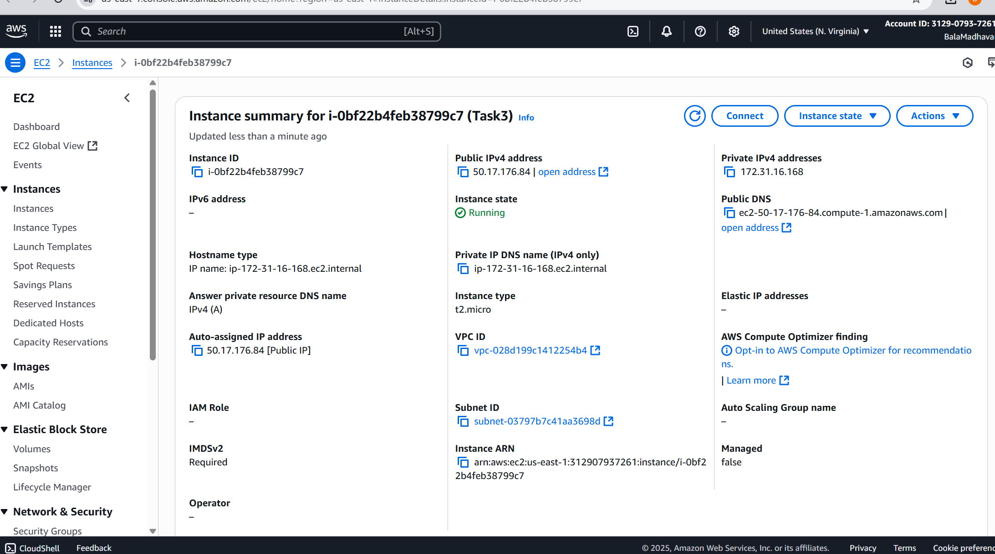

Then Connect the Instance to Install the required tools.

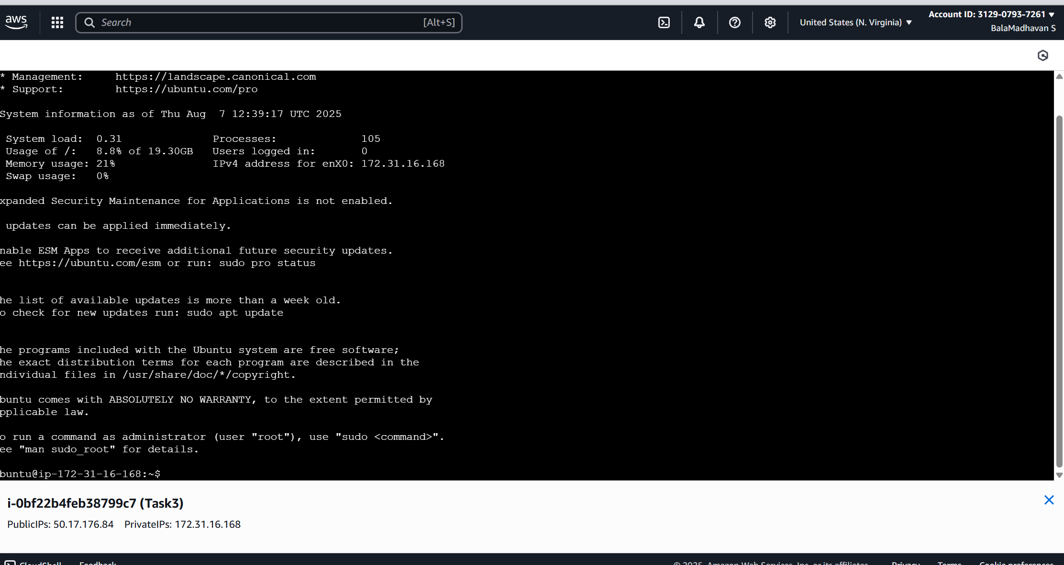

Step :- 2

Now Install the required tools (Docker & Terraform).

sudo apt update

sudo apt install -y docker.io

sudo usermod -aG docker $USER

newgrp docker

docker --version

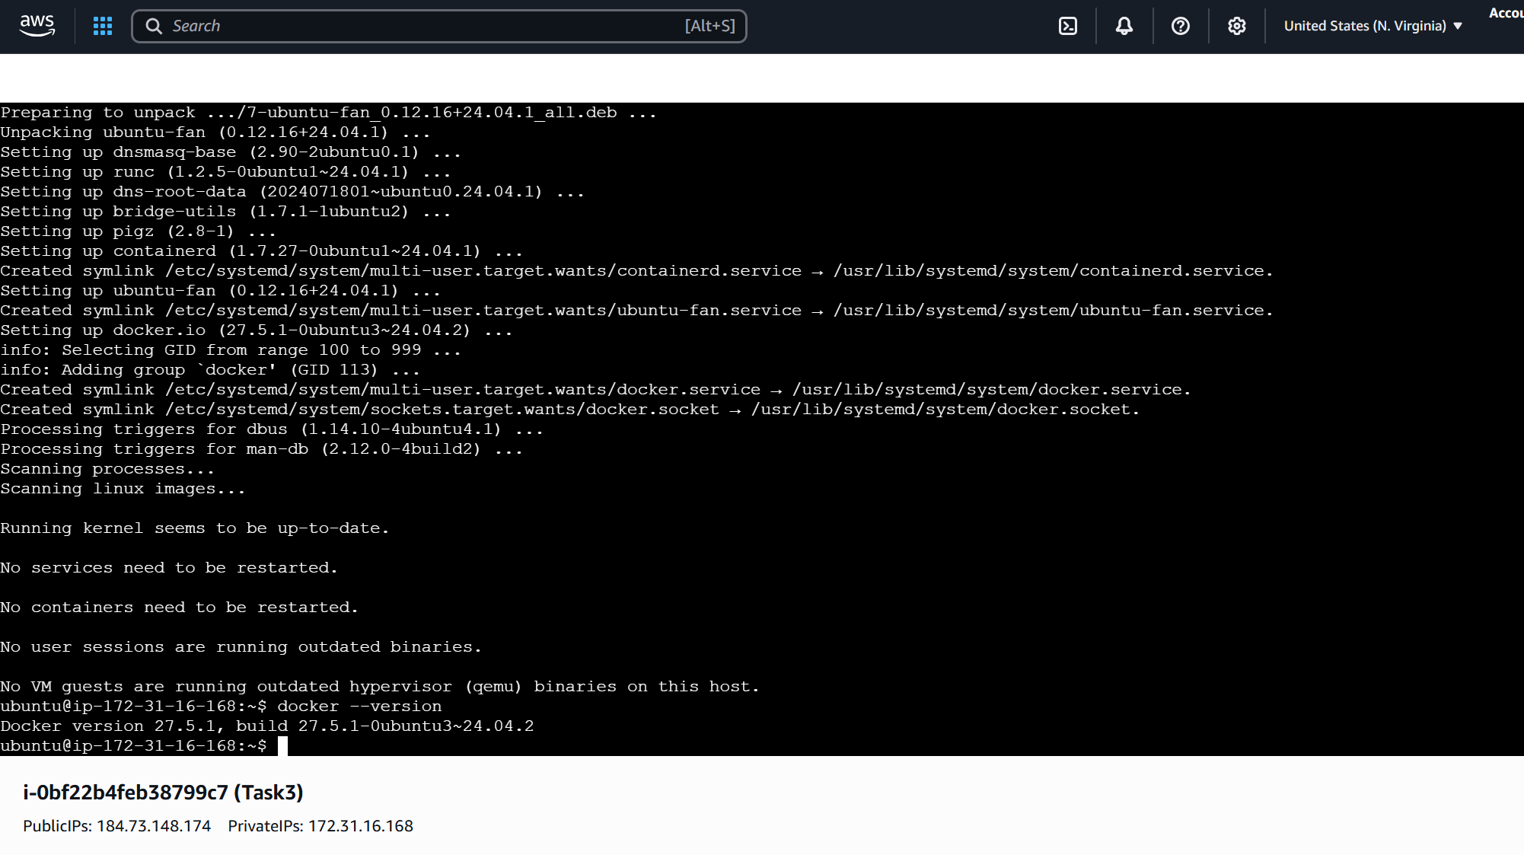

sudo apt install -y curl unzip

curl -fsSL https://releases.hashicorp.com/terraform/1.8.0/terraform_1.8.0_linux_amd64.zip -o terraform.zip

unzip terraform.zip

sudo mv terraform /usr/local/bin/

terraform -v

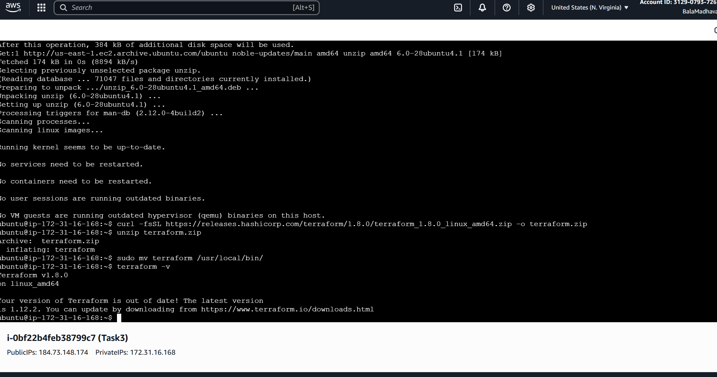

Step :- 3

Now Provision Docker Container using Terraform :

Create Project Directory :

mkdir terraform-docker

cd terraform-docker

nano main.tf

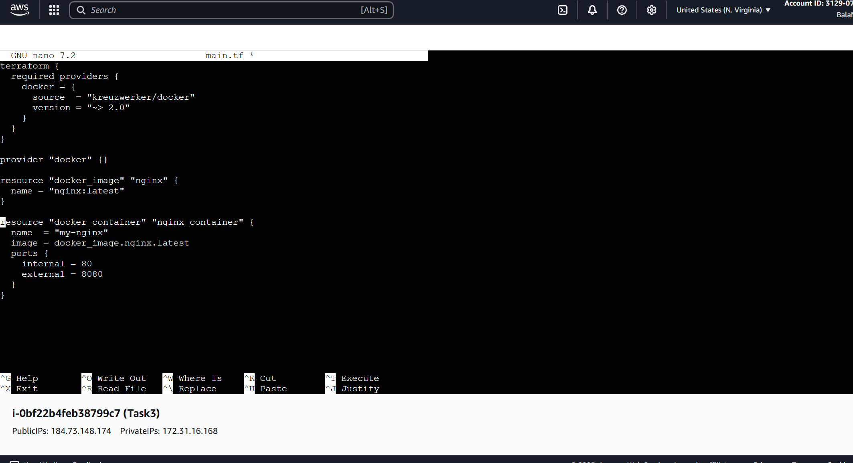

Step :- 4

Now Terraform commands to Execute with logs.

Terraform init

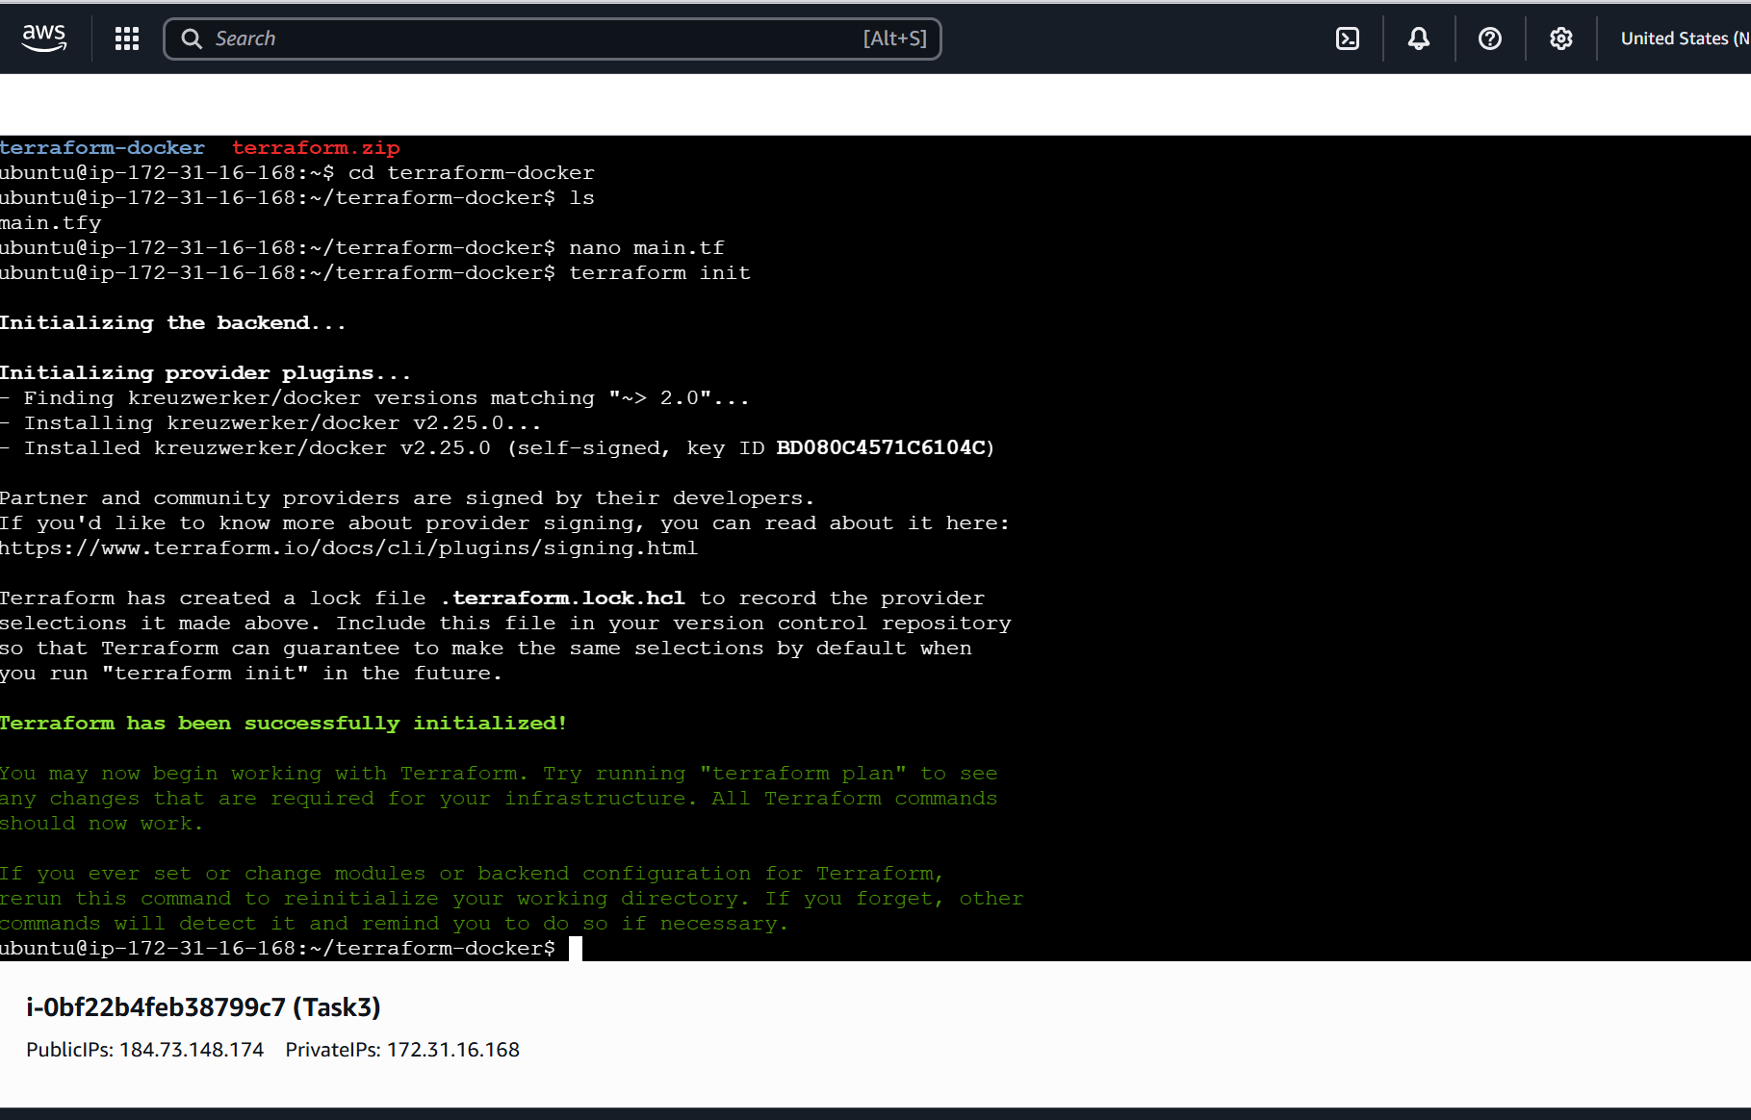

Terraform initialize successfully.

Then, Enter commands

Terraform plan

Terraform apply – to provisions the Docker container

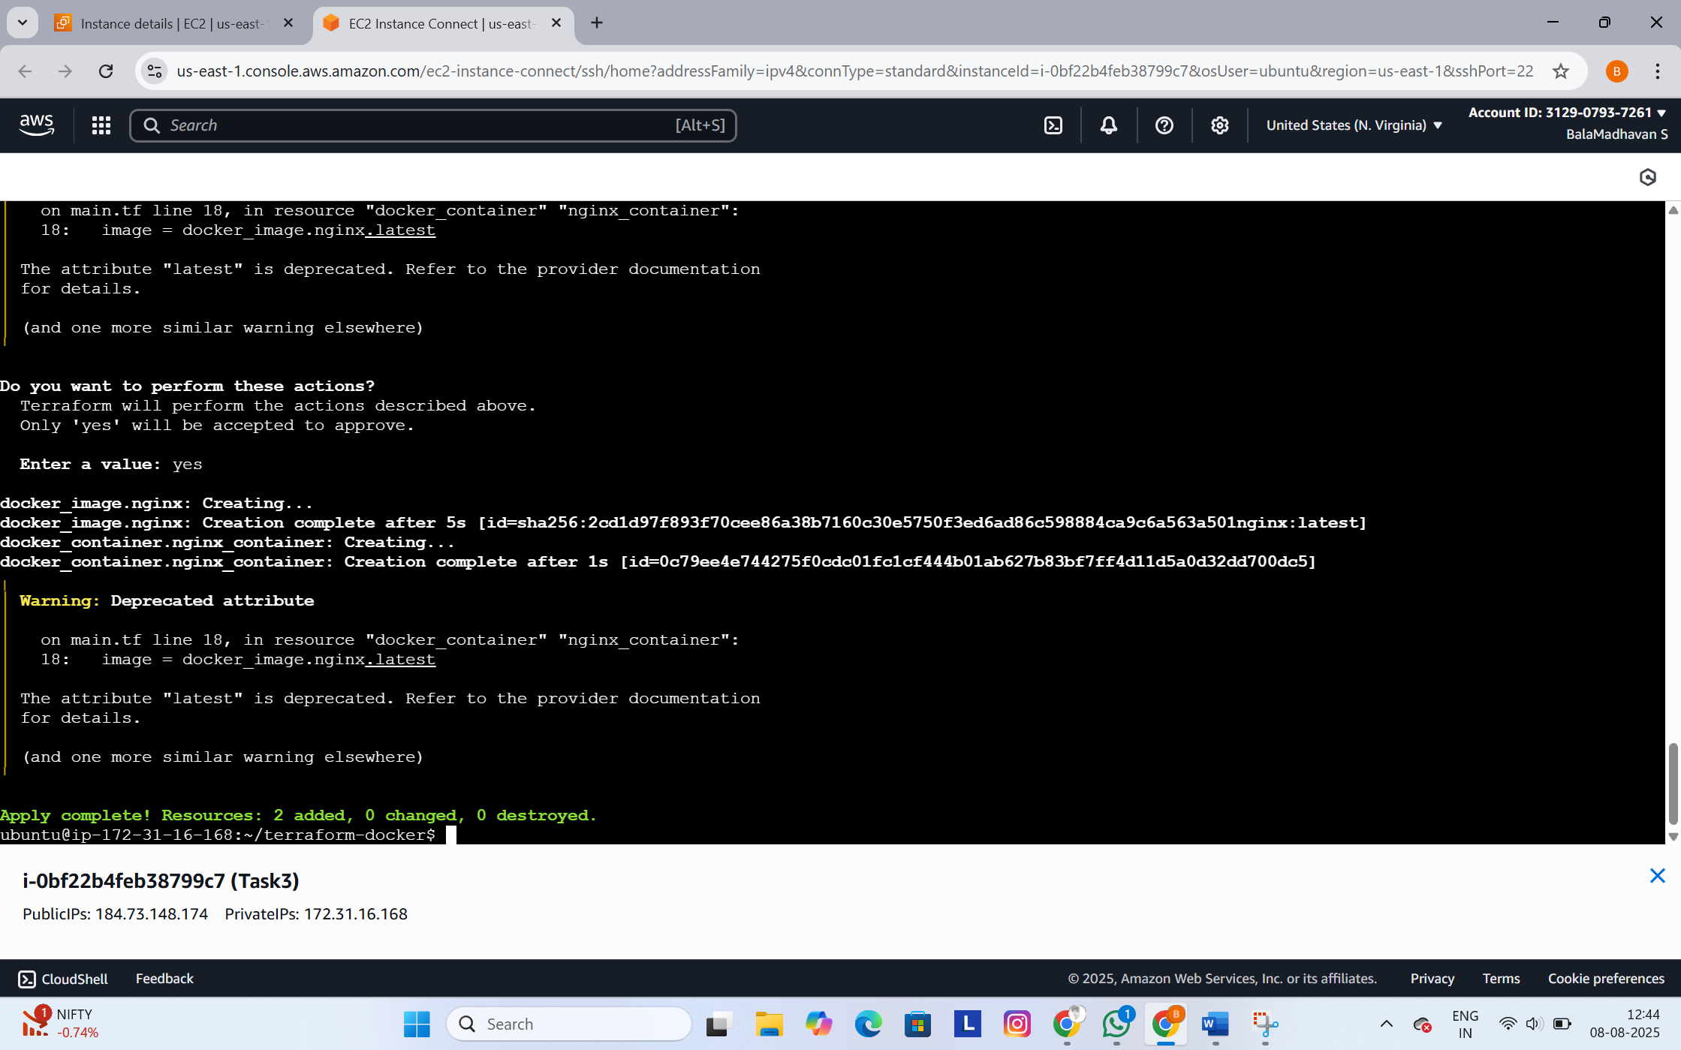

Enter **docker ps** command to confirms container is running

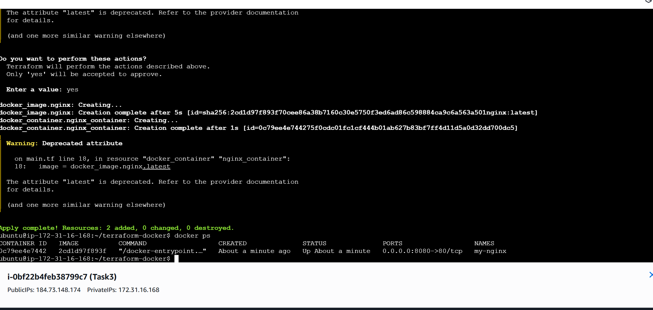

Now Enter **terraform state list** command to shows resources in the current state

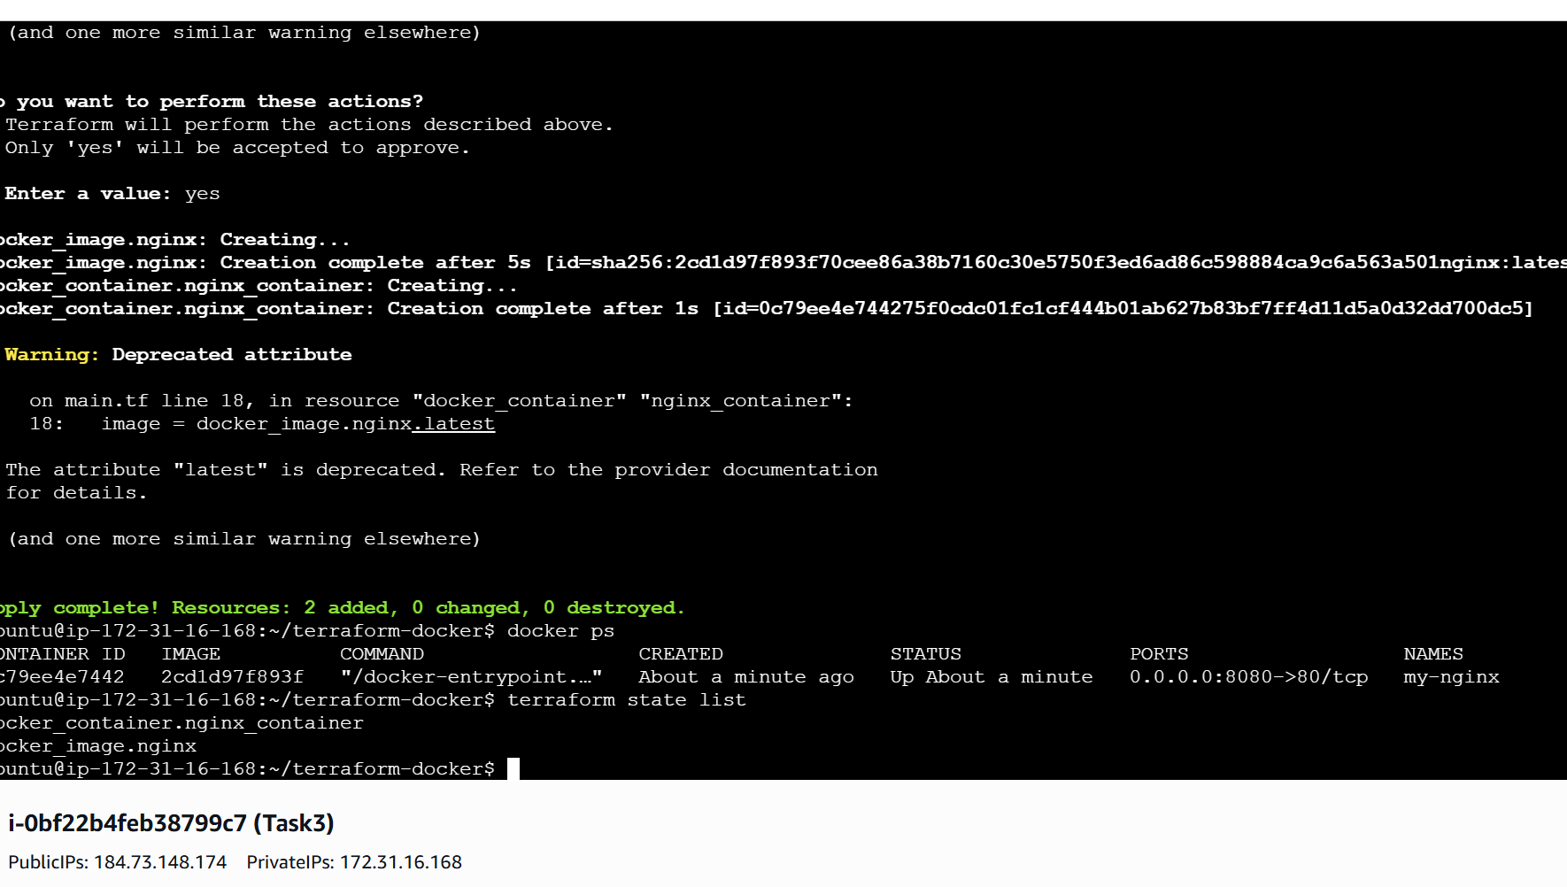

Step :-5

Now go to security and edit inbound rules , add rules

Custom TCP port number 8080 and select anywhere ipv4

Ans save the rule.

Then, copy the public ip and add port number 8080 and paste on the browser , you see the Welcome page of NGINX

